MIT Assignment-06

Jeetu Mehra
U24AI032

Question 1 : Load the hexad ecim al num bers 9BH and A7H to reg isters D and E, resp ectively, And add
the num bers. If result is greater than FFH , disp lay 0 1H at output port 0000 H, otherwise
disp lay answer.
Output:
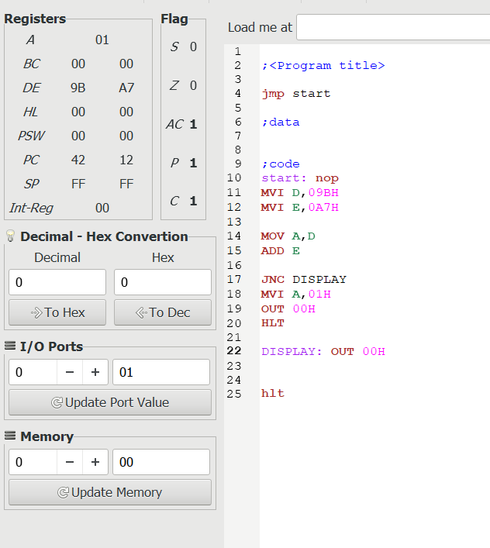

Question 2: Write Instruction to clear CY flag ,to load num b er FFH in B, and increment B. If the CY
flag is set, display 01 at the output port; otherwise, display the contents of register B.
Output:
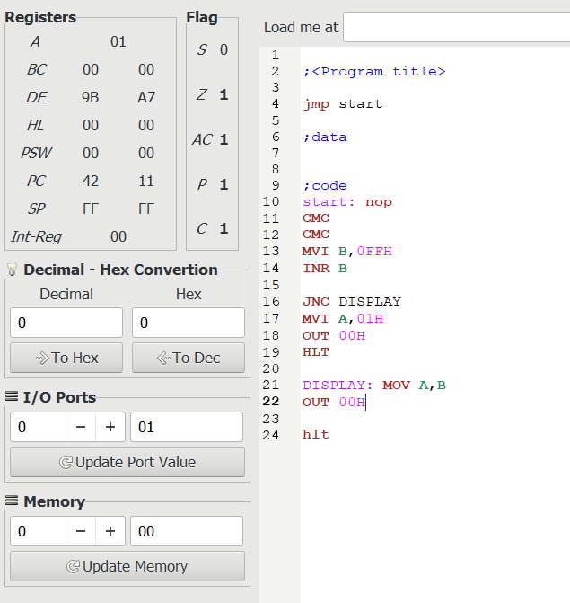

Question 3: Write a program to perform multiplication of two 8 bit numbers using bit addition method.
Output:
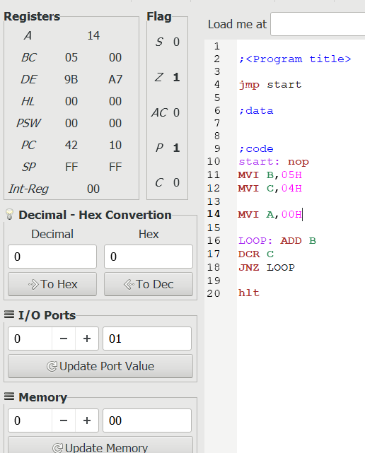

Question 4 : Write a program to perform square and cube of five numbers of two 8 bit numbers using bit
rotation method.
Output:
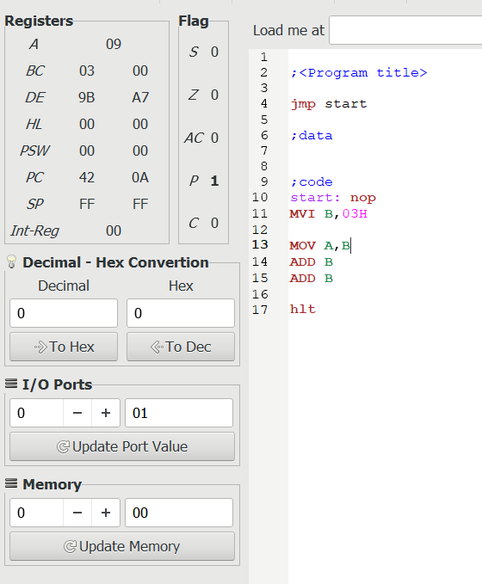

Question 5 : Write a program to perform division of two 8 bit numbers using Repeated Subtraction
method.
Output:
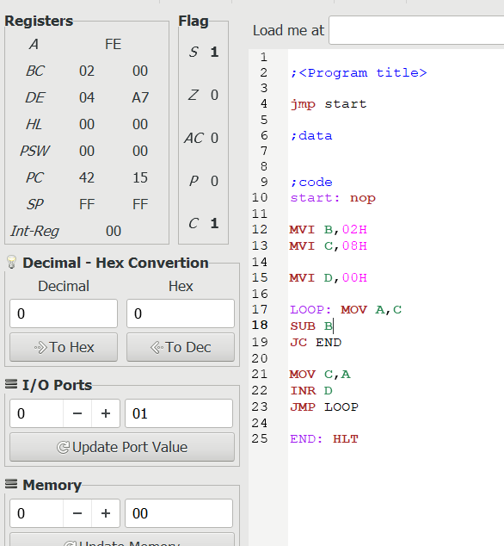

Question 6 : Write a program to perform multiplication of two 8 bit numbers using bit rotation method.
Output:
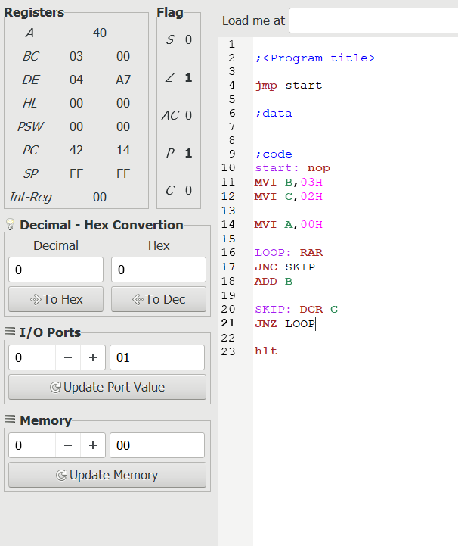

Question 7 : Finding the largest and smallest number from an array.
Output:
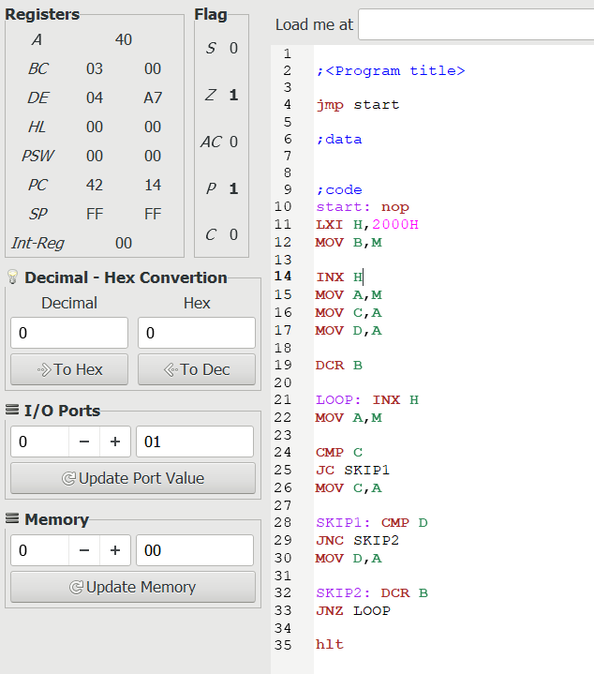

Question 8 : Write a program to perform summation of first 10 numbers.
Output:
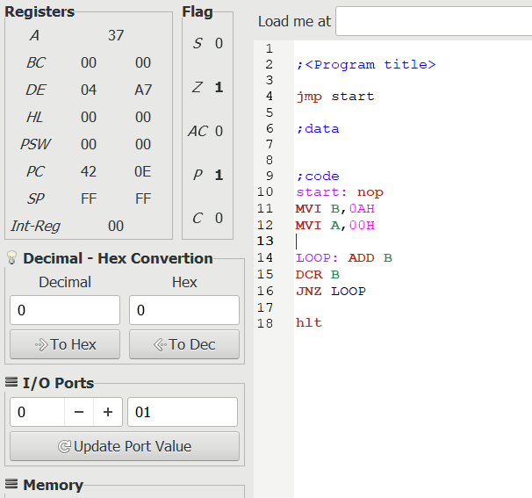

Question 9 : Write an 8085 program to copy block of five numbers starting from location
2001h to locations starting from 3001h.
Output:
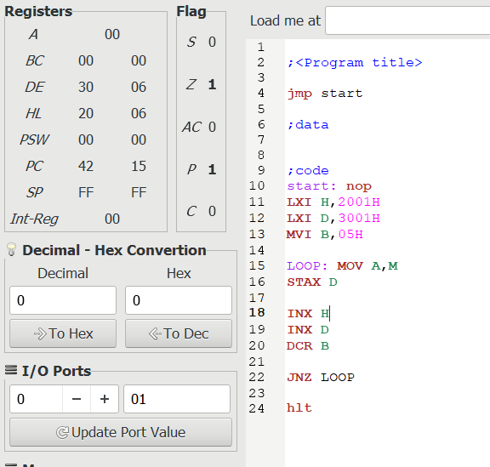

Question 10 : Write an assembly language program to check if a given number is even or odd. Store 0 if the
number is even and 1 if it is odd.
Output:

